**Interleaved memory**

* Interleaved memory is designed to compensate for the relatively slow speed of dynamic random-access memory (D-RAM) or core memory by spreading memory addresses evenly across memory banks. ​
* Hence, the CPU can access alternate sections immediately without waiting for memory to be cached. There are multiple memory banks that take turns for the supply of data.
* When the processor requests data from the main memory, a block (chunk) of data is transferred to the cache and then to processor. So whenever a cache miss occurs, the data is to be fetched from the main memory. But main memory is relatively slower than the cache. So to improve the access time of the main memory, interleaving is used.​

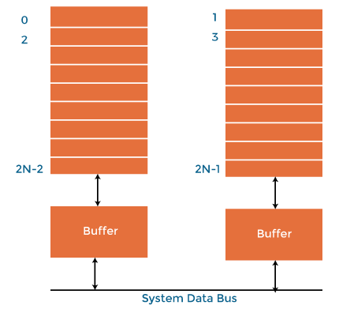

* **Types of Interleaved Memory​:**

In an operating system, interleaved memory could be of the following 2 types:​

* High order interleaving​
* In high order memory interleaving, the most significant bits (MSB) of the memory address decides memory banks where a particular location resides. ​
* The least significant bits are sent as addresses to each chip. ​
* One problem is that consecutive addresses tend to be in the same chip. ​
* Low order interleaving​
* The least significant bits (LSB) select the memory bank (module) in low-order interleaving. ​
* In this case, consecutive memory addresses are in different memory modules
* Advantages of Memory Interleaving:

1. It allows simultaneous access to different modules of memory. The modular memory technique allows the CPU to initiate memory access with one module while others are busy with the CPU in reading or write operations. ​
2. Interleaved memory makes a system more responsive and faster compared to non-interleaving. ​
3. Due to simultaneous memory access, the CPU processing time also decreases and increasing throughput. ​

**Associative memory**

* **Associative memory** also known as content addressable memory (CAM) is a special type of memory that is optimized for performing searches through data, as opposed to providing a simple direct access to the data based on the address.

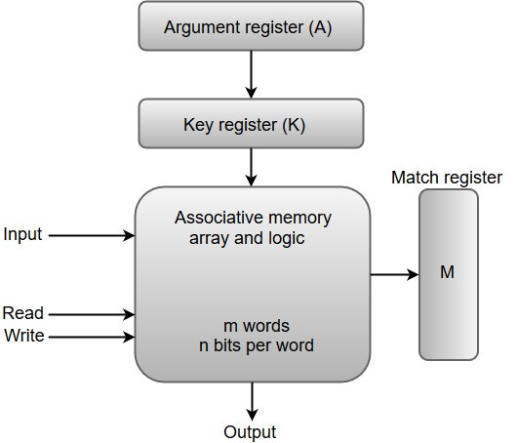

* The argument to be searched is provided to the argument register.
* Searches can be done in 2 ways:
* Searching on the entire argument.
* Searching on a part within the argument
* The key register is provided with a mask pattern that indicates the bits of argument to be included for search pattern.
* If any bit is 0 in the mask pattern, then the corresponding bit of argument register should not be included in the search.
* For an entire argument search the key register is supplied with all 1’s.
* Example:

A = 10111100

K = 11100000

Word1 = 10011100 no match

Word2 = 10110001 match